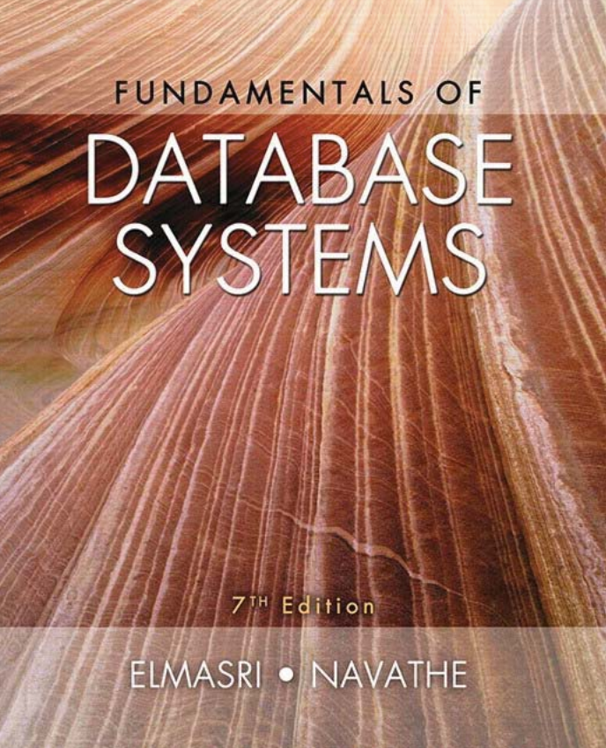
Database System
Concepts ﬁ
Chapter 1





REVISION 1

-------------------------------------------------
Terms (GNU AGPLv3)
This is just a sample!
I have tried to put things like summary, and obviously this is not the solution that I will submit or recommended! I am no way responsible for any illegal use of this file.

If you need direct solutions, please ask ChatGPT, Google Gemini, Anthropic Claude, Hugging Chat, Le Chat Mistral or any other predictive model.

Chapter 1 | Review Questions

Define the following terms:
- Data
- database
- DBMS, database system, database catalog, program-data independence, user view, DBA, end user, canned transaction, deductive database system, persistent object, meta-data, and transaction-processing application.

1.2. What four main types of actions involve databases? Briefly discuss each.
1.3. Discuss the main characteristics of the database approach and how it differs
from traditional file systems.
1.4. What are the responsibilities of the DBA and the database designers?
1.5. What are the different types of database end users? Discuss the main activi-
ties of each.
1.6. Discuss the capabilities that should be provided by a DBMS.
1.7. Discuss the differences between database systems and information retrieval
systems.
1.8. Identify some informal queries and update operations that you would expect
to apply to the database shown in Figure 1.2.
1.9. What is the difference between controlled and uncontrolled redundancy?
Illustrate with examples.
1.10. Specify all the relationships among the records of the database shown in
Figure 1.2.
1.11. Give some additional views that may be needed by other user groups for the
database shown in Figure 1.2.
1.12. Cite some examples of integrity constraints that you think can apply to the
database shown in Figure 1.2.
1.13. Give examples of systems in which it may make sense to use traditional file
processing instead of a database approach.
1.14. Consider Figure 1.2.
a. If the name of the ‘CS’ (Computer Science) Department changes to ‘CSSE’
(Computer Science and Software Engineering) Department and the cor-
responding prefix for the course number also changes, identify the col-
umns in the database that would need to be updated.
b. Can you restructure the columns in the COURSE , SECTION, and
PREREQUISITE tables so that only one column will need to be updated?

